**Question:1 2 bit by 2 bit multiplier**

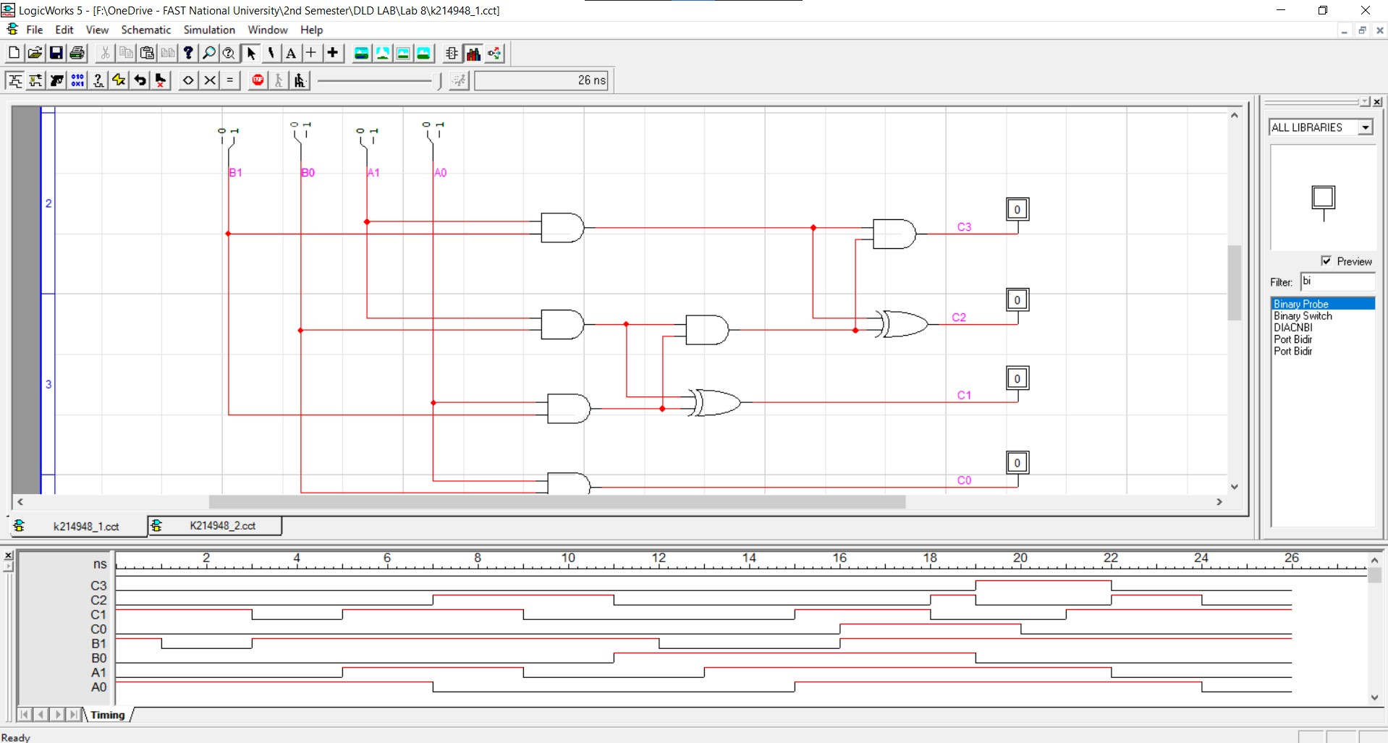

**Question:2 3 bit by 3 bit multiplier**

